============================= Exception handling in Spring Boot =========================
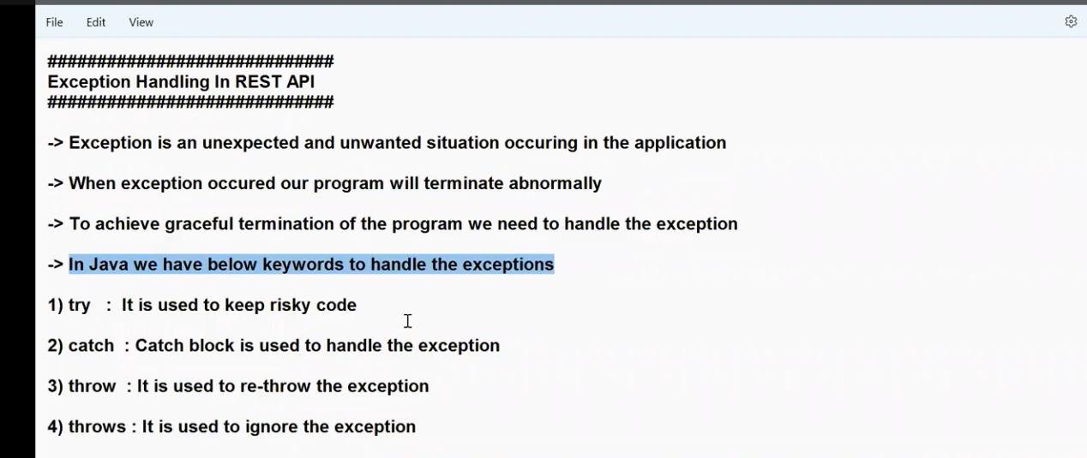

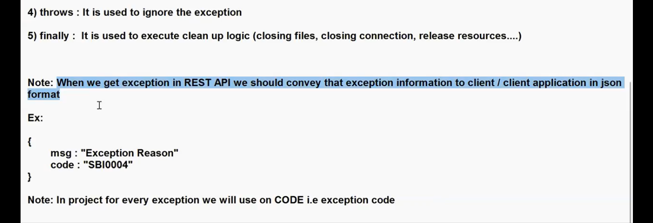

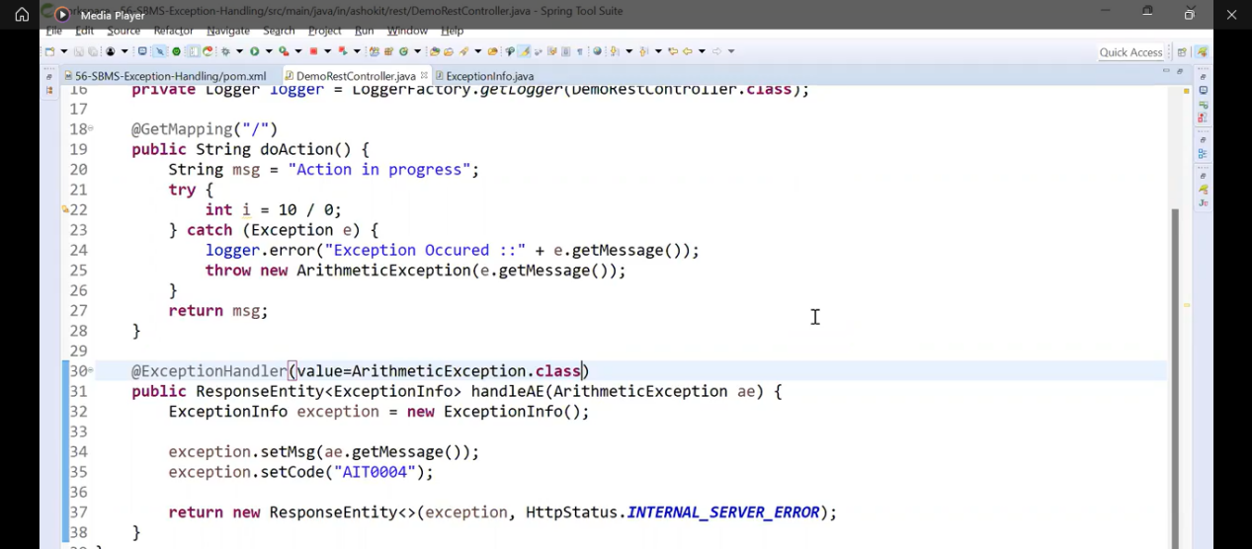

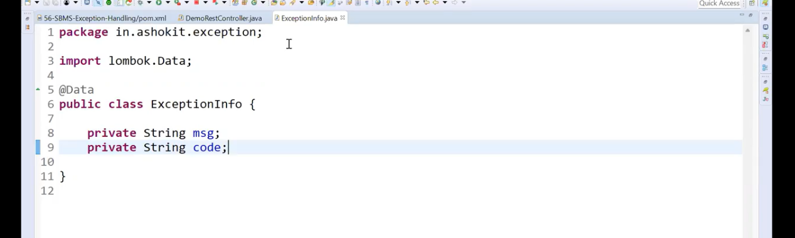
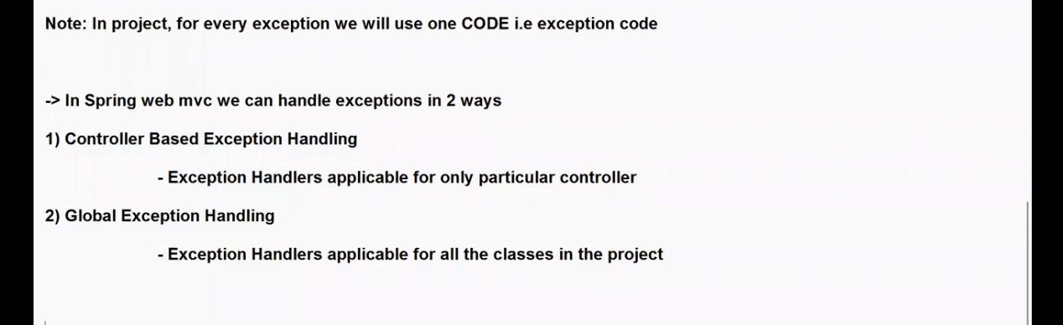

Note : Exception handling ki complete Projetct chesanu

What will happened if we don’t know what Exception it will occurred ?

🧩 1. If You Know the Exception Type
Yes — you can handle it specifically like:
@ExceptionHandler(value = ArithmeticException.class)
public ResponseEntity<ExceptioDAO_Class> handleArithmeticException(ArithmeticException ex) {
...
}
✅ Use this for known, expected, or business-specific exceptions (e.g., UserNotFoundException, InvalidTokenException, etc.).

🌍 2. If You Don’t Know the Exception Type
You can create a generic catch-all exception handler that catches everything else:
@ExceptionHandler(value = Exception.class)
public ResponseEntity<ExceptioDAO_Class> handleGlobalException(Exception ex) {
ExceptioDAO_Class errorResponse = new ExceptioDAO_Class();
errorResponse.setMsg("Something went wrong: " + ex.getMessage());
errorResponse.setErrorCode("GEN-001");
return new ResponseEntity<>(errorResponse, HttpStatus.INTERNAL_SERVER_ERROR);
}
✅ This ensures no unhandled exception ever leaks to the client.
✅ It’s a safety net for unexpected runtime or framework errors.

⚙️ 3. Real-Time Best Practice (What Companies Do)
In real projects, developers combine both:
Type | Example | Purpose
🎯 Specific Handlers | @ExceptionHandler(UserNotFoundException.class) | For expected business errors — to return meaningful HTTP status & message
🌍 Generic Handler | @ExceptionHandler(Exception.class) | For all other unexpected errors — to prevent raw stack traces from leaking
Typical structure in a Global Exception Handler:
@RestControllerAdvice
public class GlobalExceptionHandler {

// 1️⃣ Business-specific
@ExceptionHandler(UserNotFoundException.class)
public ResponseEntity<ExceptioDAO_Class> handleUserNotFound(UserNotFoundException ex) {
ExceptioDAO_Class err = new ExceptioDAO_Class();
err.setMsg("User not found");
err.setErrorCode("USR-404");
return new ResponseEntity<>(err, HttpStatus.NOT_FOUND);
}

// 2️⃣ Validation-specific
@ExceptionHandler(MethodArgumentNotValidException.class)
public ResponseEntity<ExceptioDAO_Class> handleValidation(MethodArgumentNotValidException ex) {
ExceptioDAO_Class err = new ExceptioDAO_Class();
err.setMsg("Validation failed: " + ex.getMessage());
err.setErrorCode("VAL-400");
return new ResponseEntity<>(err, HttpStatus.BAD_REQUEST);
}

// 3️⃣ Catch-all fallback
@ExceptionHandler(Exception.class)
public ResponseEntity<ExceptioDAO_Class> handleAll(Exception ex) {
ExceptioDAO_Class err = new ExceptioDAO_Class();
err.setMsg("Internal Server Error: " + ex.getMessage());
err.setErrorCode("GEN-500");
return new ResponseEntity<>(err, HttpStatus.INTERNAL_SERVER_ERROR);
}
}

✅ Summary Table
Situation | What You Do | Example
You know exactly what exception can occur | Write a specific @ExceptionHandler | @ExceptionHandler(ArithmeticException.class)
You don’t know or want to handle all cases | Write a generic @ExceptionHandler(Exception.class) | @ExceptionHandler(Exception.class)
Real-time best practice | Combine specific + generic handlers in a Global Exception Handler | Shown above

💡 Final Thought:
In real-time projects, you don’t have to know every exception —
but you should handle all expected ones explicitly,
and use a generic handler to catch everything else.
what will happened if Common Exception Handler and Controller based handler will give same Exception? That Exception will point which block of code ?.

⚙️ 1️⃣ What actually happens inside Spring
When an exception is thrown inside a controller, Spring’s ExceptionResolver system kicks in.
Spring looks for a matching @ExceptionHandler in the following order:
Controller-specific handler (@ExceptionHandler in the same controller class)
Global handler (@ControllerAdvice / @RestControllerAdvice)
If not found → Spring’s default error handler (BasicErrorController)

🧠 2️⃣ If Multiple Handlers Can Handle the Same Exception
Let’s say you have two like this:
@ExceptionHandler(ArithmeticException.class)
public ResponseEntity<String> handleArithmetic(ArithmeticException ex) {
return ResponseEntity.badRequest().body("Arithmetic exception handled!");
}

@ExceptionHandler(Exception.class)
public ResponseEntity<String> handleAll(Exception ex) {
return ResponseEntity.internalServerError().body("Generic exception handled!");
}
Now you throw:
int result = 10 / 0; // ArithmeticException

⚖️ 3️⃣ How Spring Decides Which One to Use
Spring chooses the most specific matching handler.
So in this case:
✅ @ExceptionHandler(ArithmeticException.class) will be used,
❌ not the generic @ExceptionHandler(Exception.class).
Because:
ArithmeticException is a subclass of Exception.
Spring internally compares the inheritance hierarchy and picks the closest match to the actual thrown exception.

📘 4️⃣ Example Output
Exception Thrown | Matching Handlers | Which Executes
ArithmeticException | Arithmetic + Exception | ✅ Arithmetic handler
NullPointerException | Only Exception | ✅ Generic handler
IOException | Only Exception | ✅ Generic handler

🧩 5️⃣ Real-Time Recommendation
✅ Always write:
Specific handlers for known business or validation exceptions.
Generic handler (Exception.class) for all unknown cases.
That way:
Your known exceptions are handled with meaningful messages.
Everything else still gets a safe, consistent error response.

✅ Example (Real-Time Practice)
@RestControllerAdvice
public class GlobalExceptionHandler {

@ExceptionHandler(ArithmeticException.class)
public ResponseEntity<String> handleArithmetic(ArithmeticException ex) {
return ResponseEntity.status(HttpStatus.BAD_REQUEST)
.body("Arithmetic exception handled!");
}

@ExceptionHandler(Exception.class)
public ResponseEntity<String> handleAll(Exception ex) {
return ResponseEntity.status(HttpStatus.INTERNAL_SERVER_ERROR)
.body("Generic exception handled!");
}
}
Output when 10/0 occurs:
➡️ "Arithmetic exception handled!"
Output when NullPointerException occurs:
➡️ "Generic exception handled!"

🧩 Summary
Rule | Explanation
@ExceptionHandler(Exception.class) | Catches all exceptions
@ExceptionHandler(SpecificException.class) | Catches that exception type only
If both can handle same exception | Spring chooses the most specific match
Best practice | Combine specific + generic handlers in one class

